Answer 10
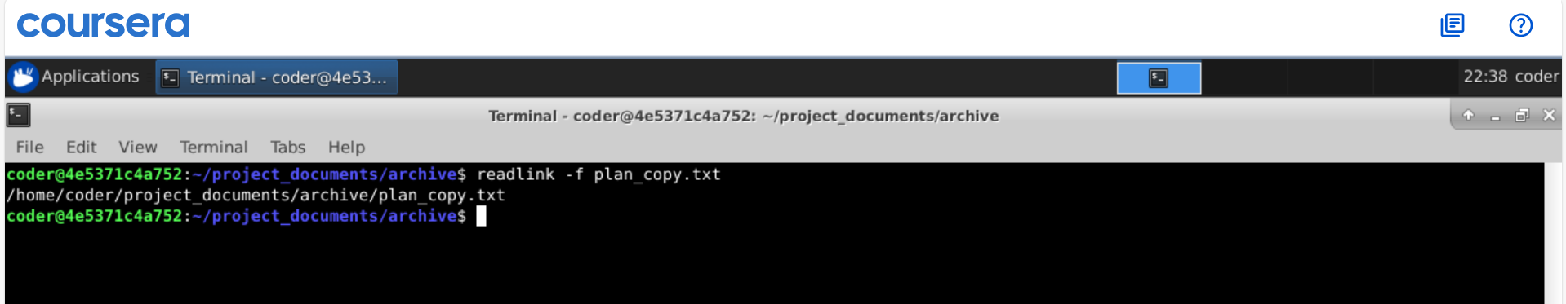
Explanation: So readlink command with -f option shows the absolute patch to the file. But for this we need to be in the file location else we need to provide the patch to the file.

